**Module 1_ AWS_Fundamentals_Cloud**

==================================================================================

Submitted to Vikul_Sir

Submitted by Nalathati Rahul

Submission Date –03/Feb/2026

==================================================================================

L6 - Create S3 Bucket and add folders and files

Step:1 login into AWS console and Search s3 in Search bar

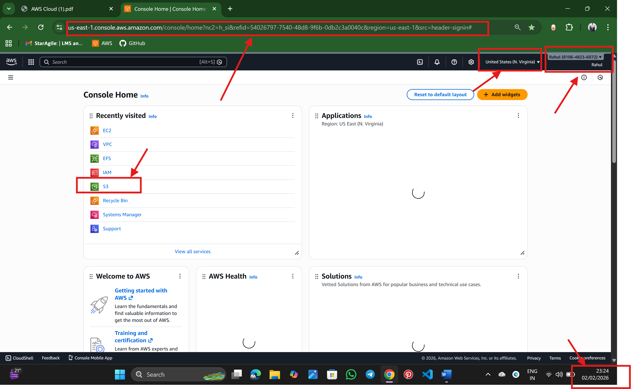

Step:2 click on create a bucket

🡪click bucket type

🡪give bucket name (unique)

🡪enable ACLs

🡪unblock public access and acknowledge it

🡪enable bucket versioning

🡪click create bucket

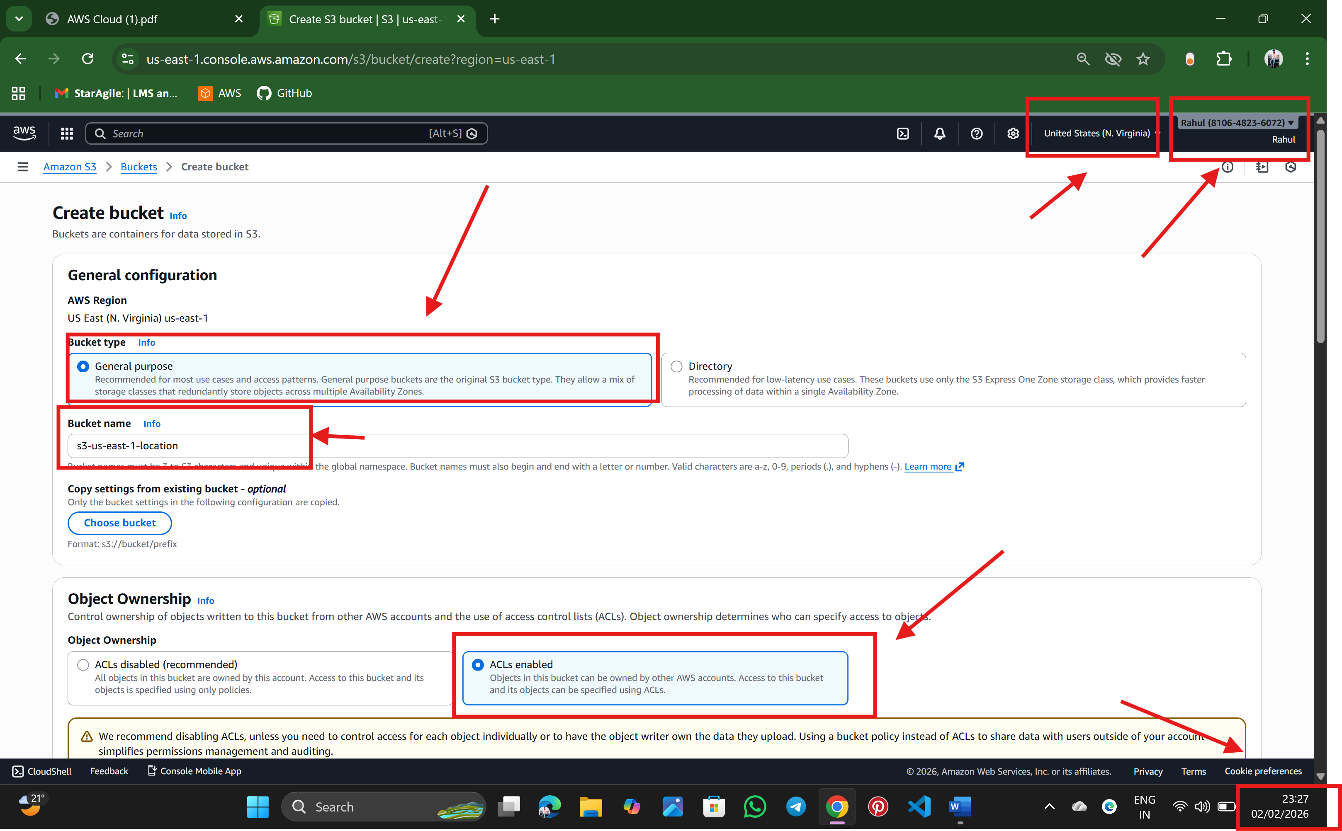

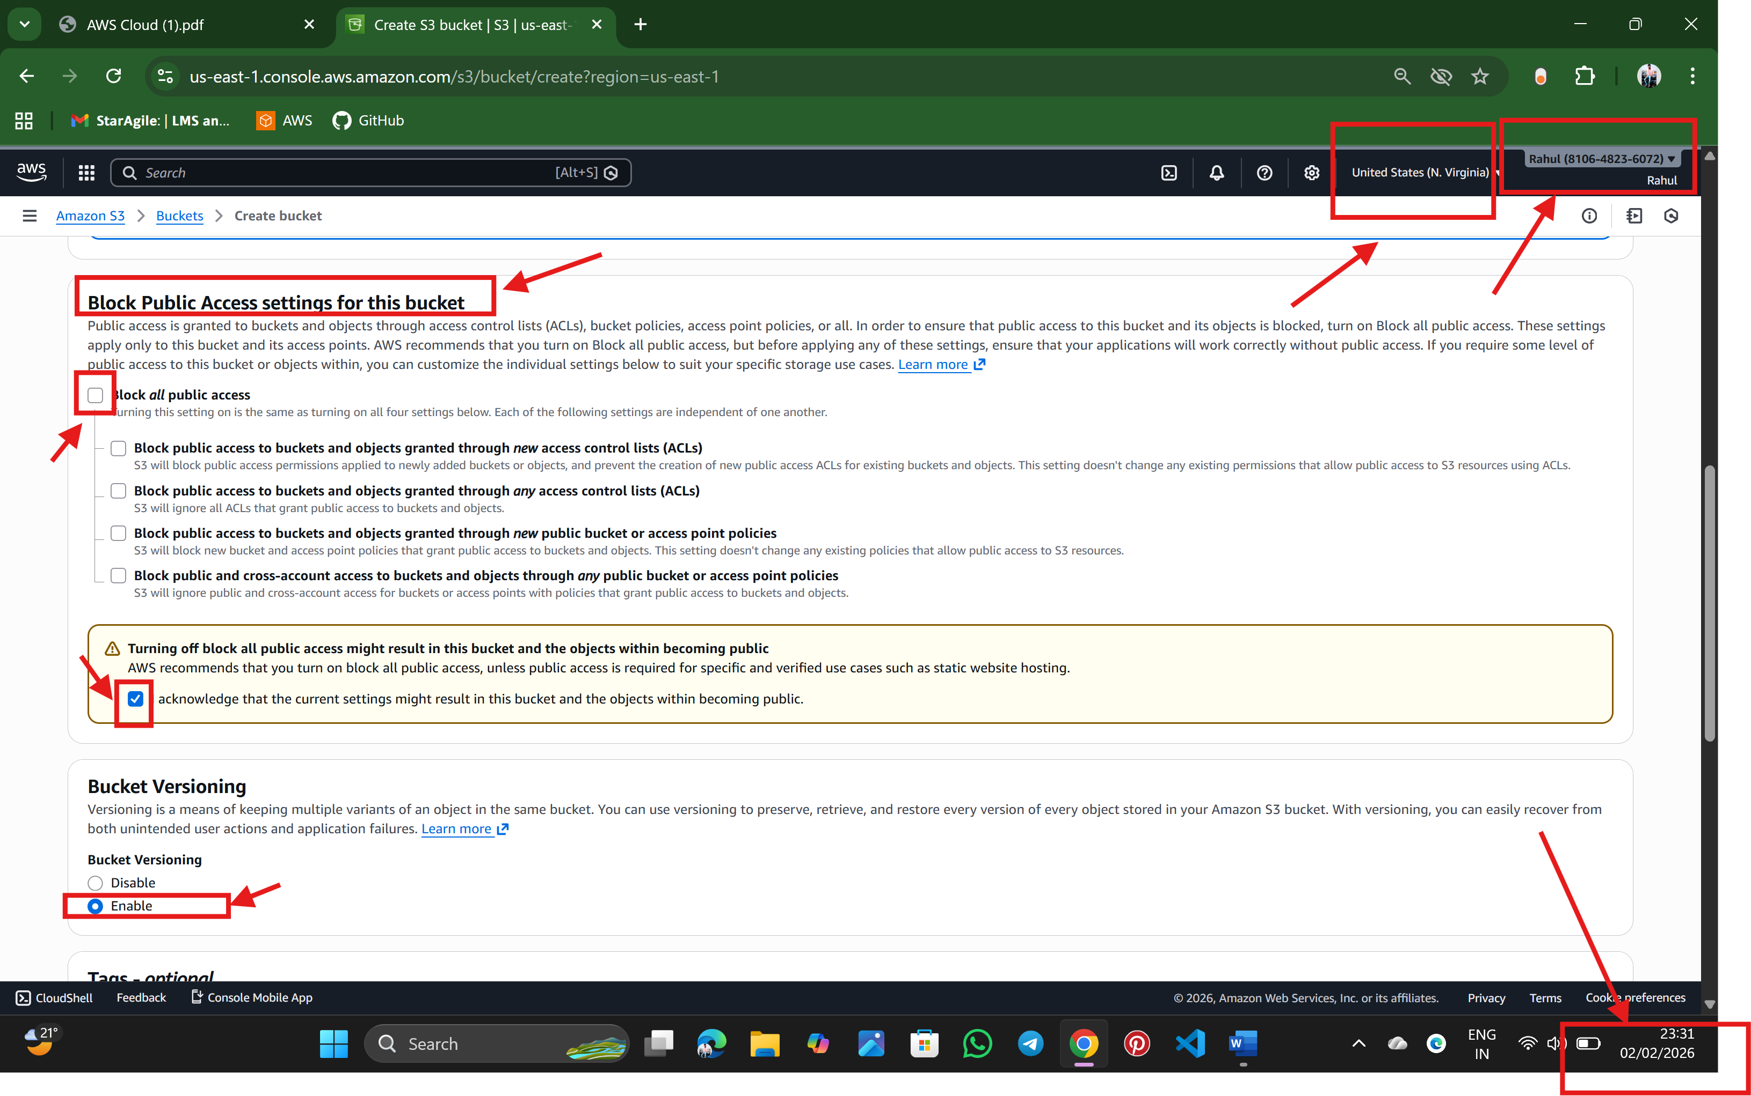

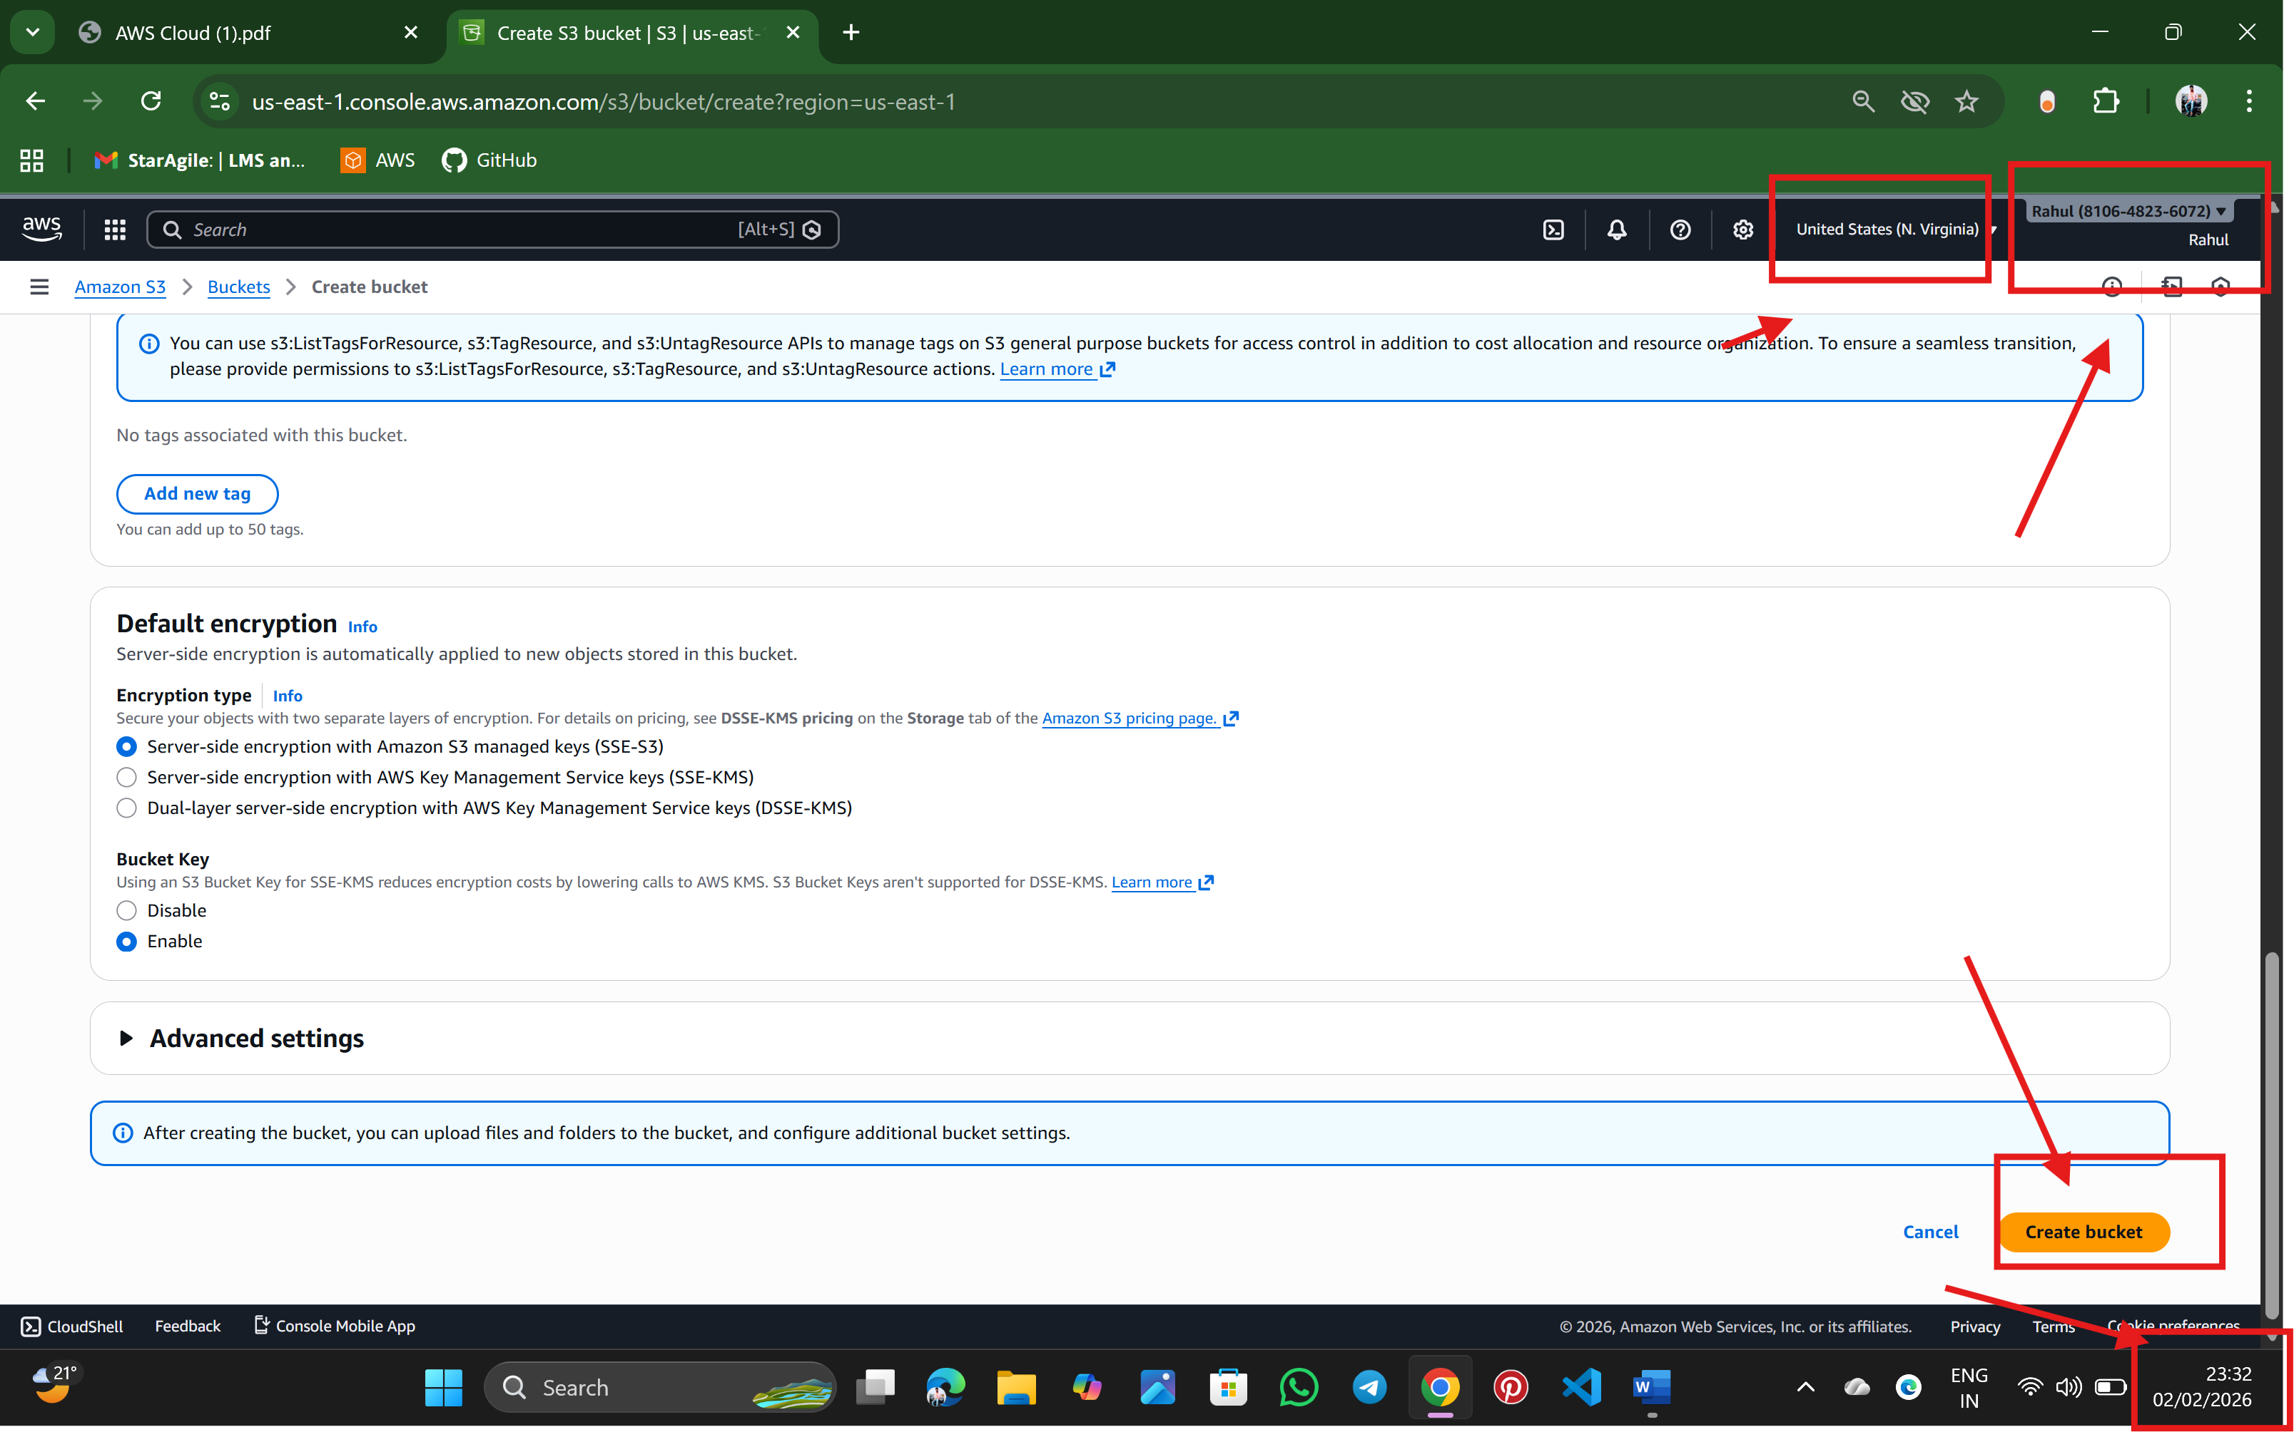

Step:3 Bucket is successfully created

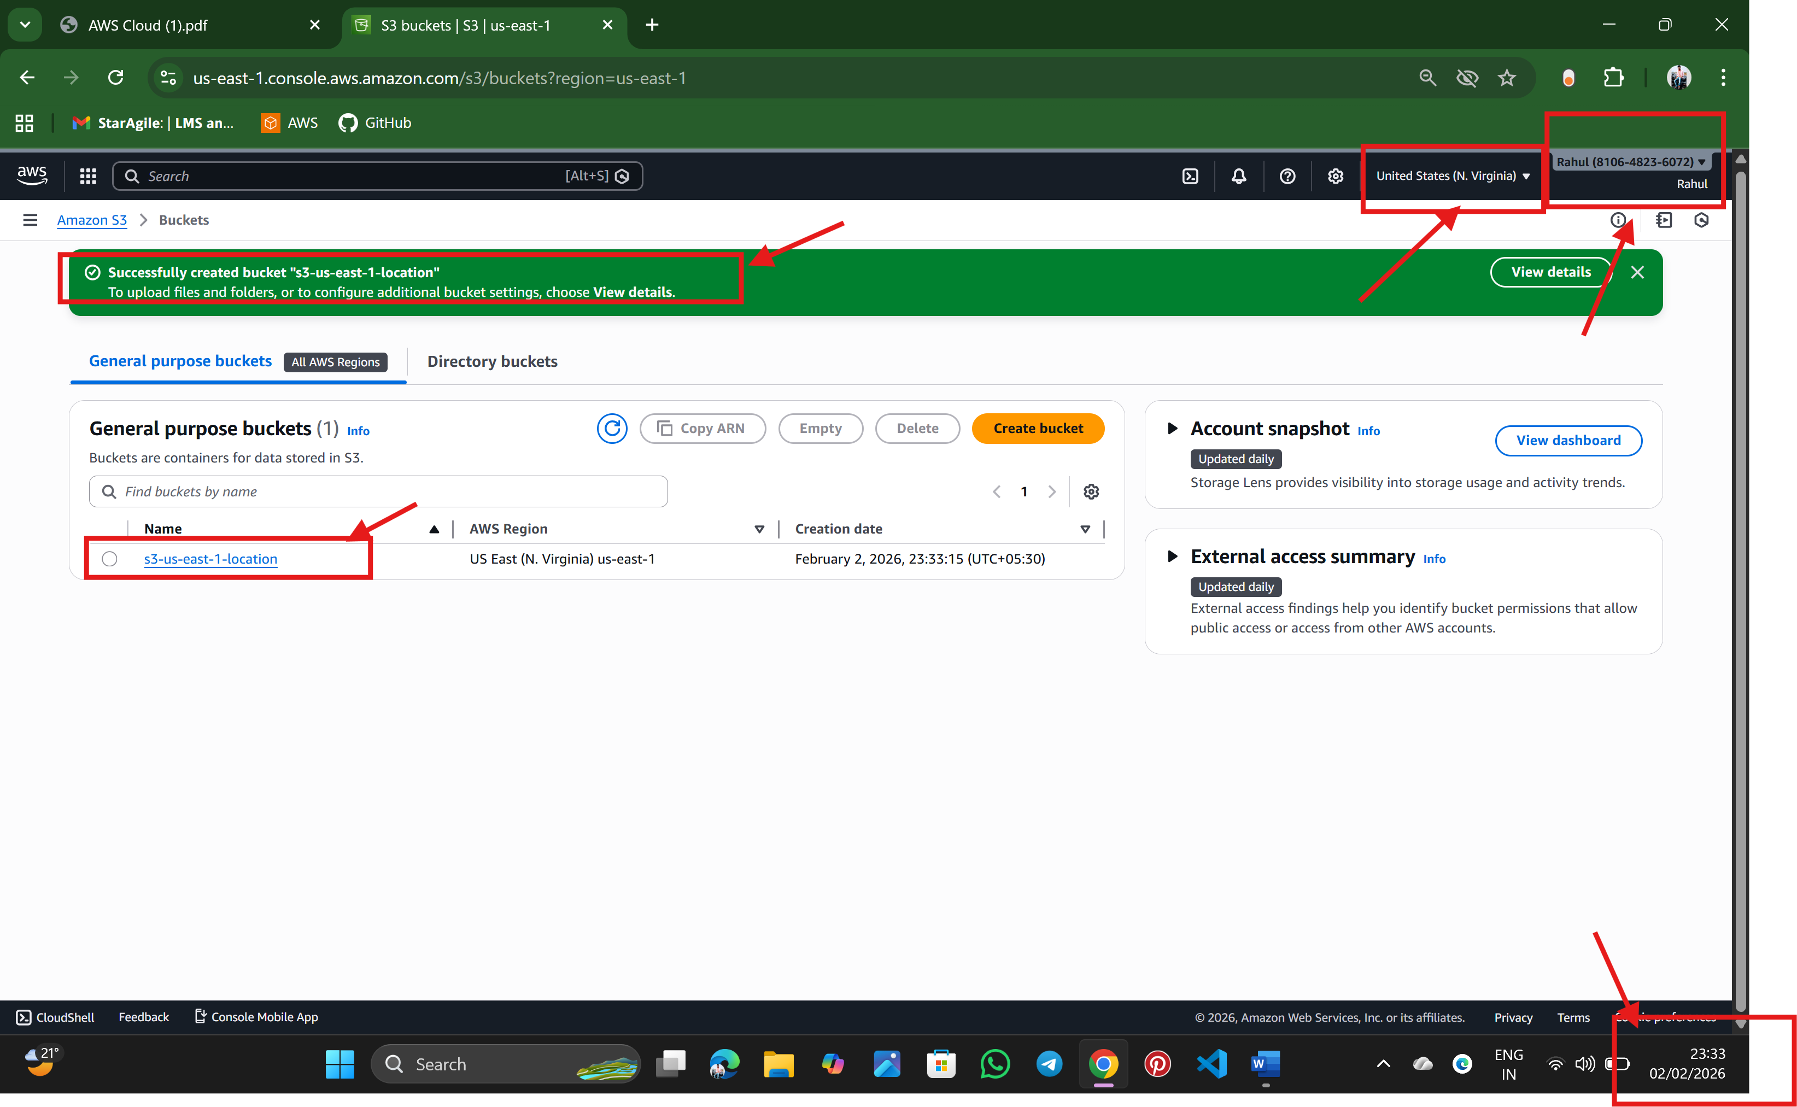

Step:4 upload object/files through upload by click it and add files and upload

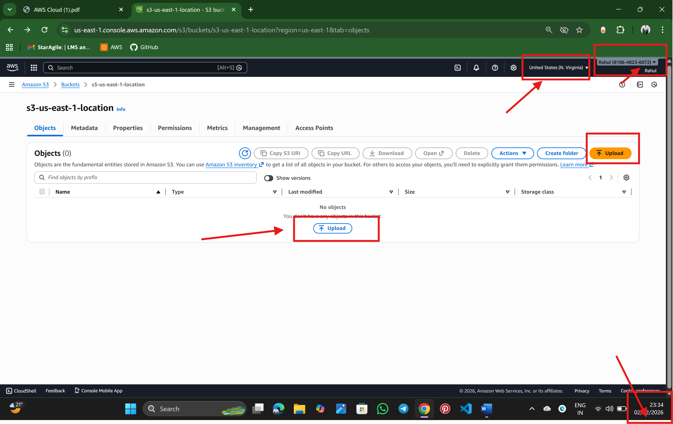

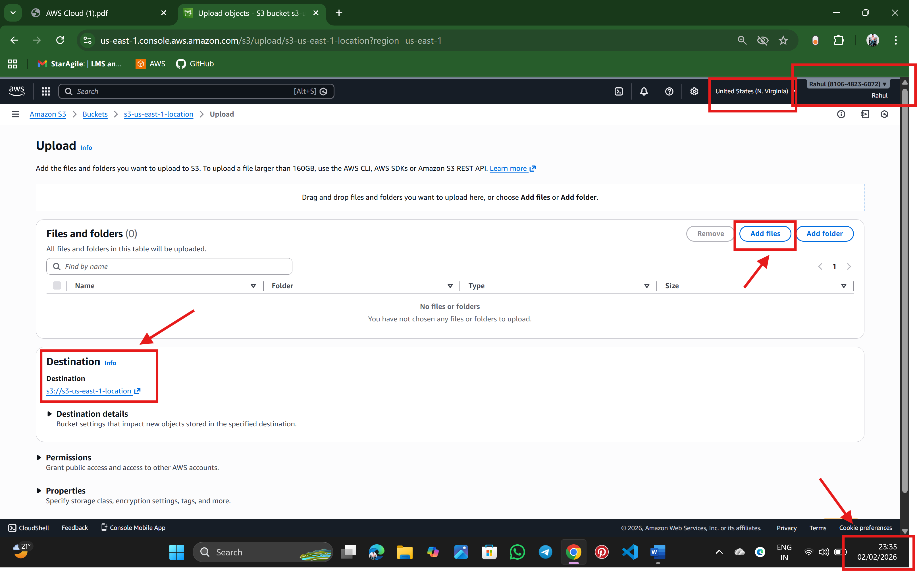

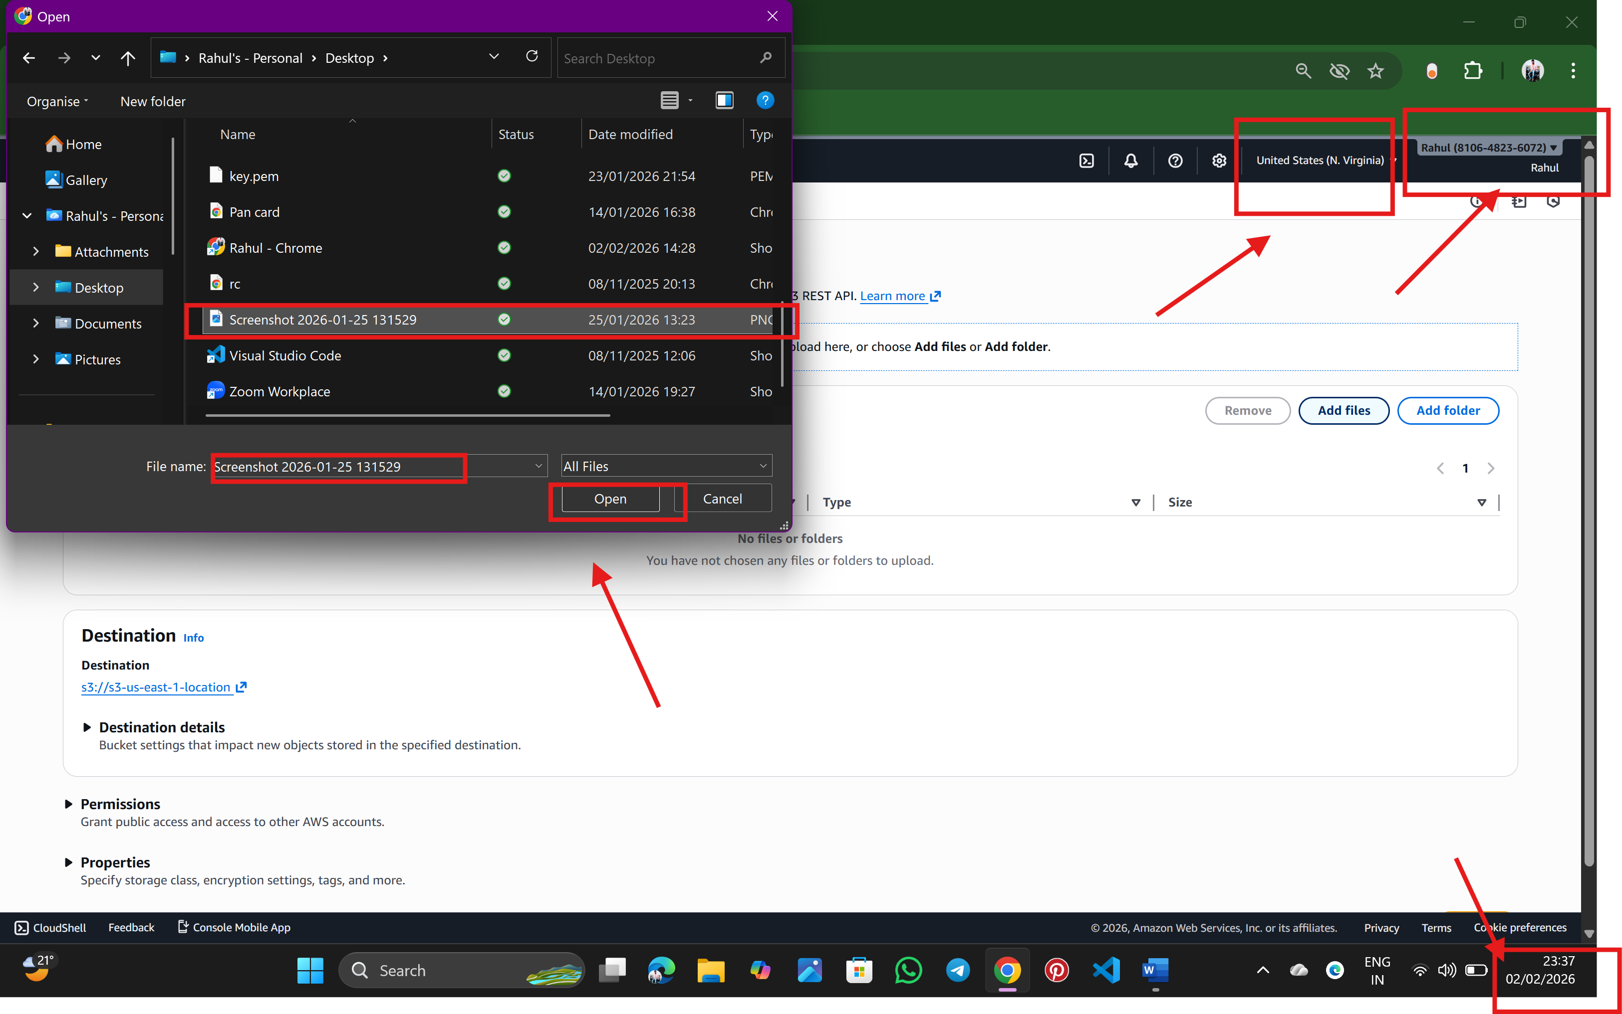

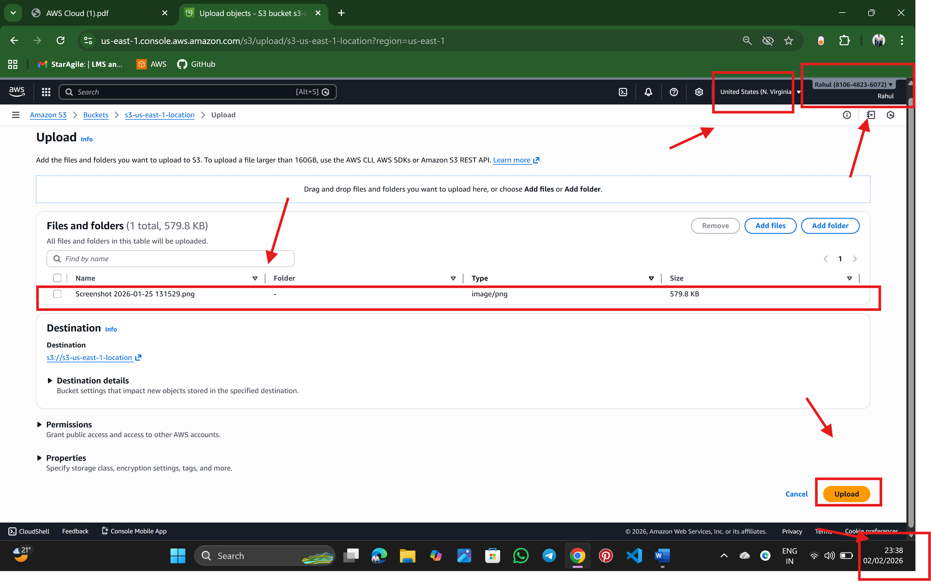

Step:5 now upload is succeeded

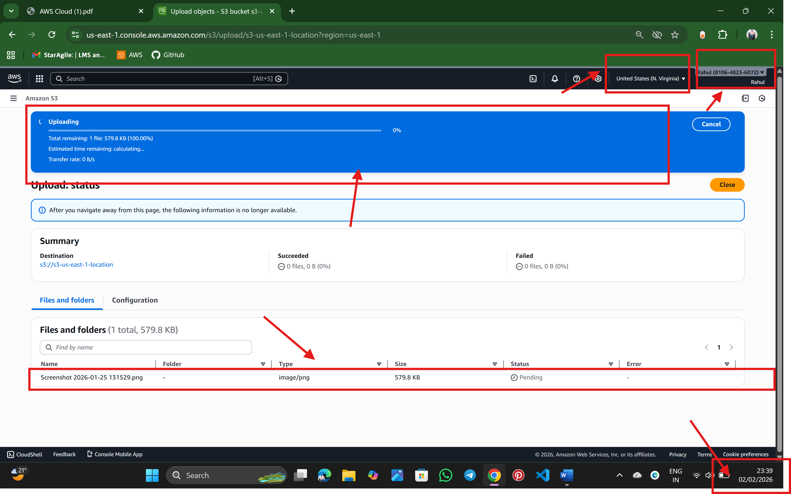

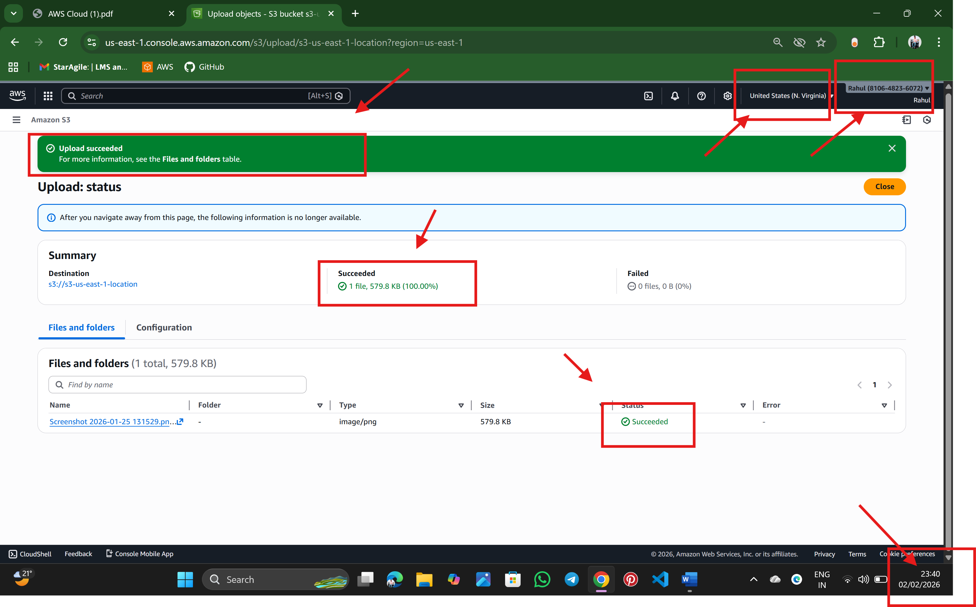

Step:6 In object actions 🡪 make public using ACL and make public

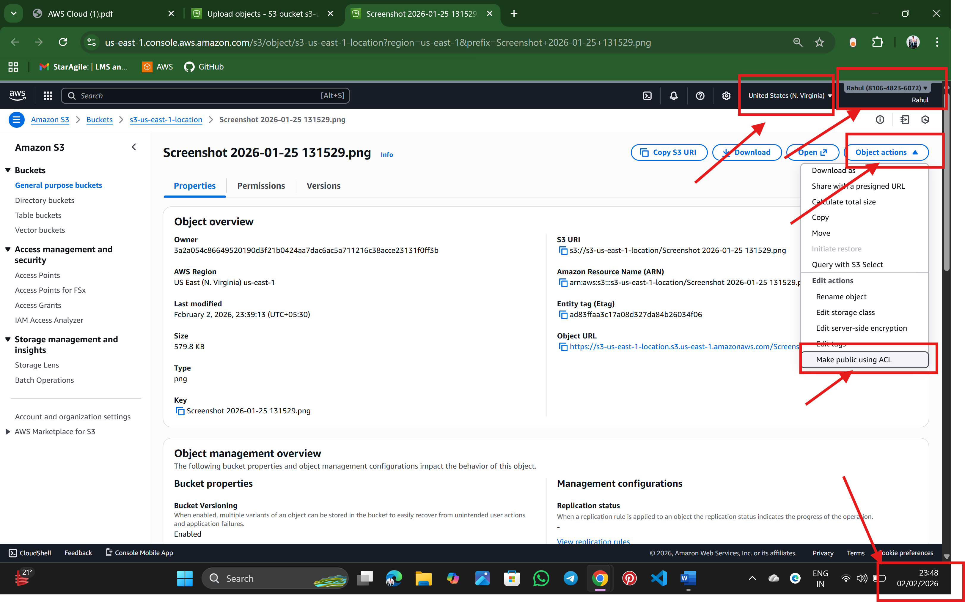

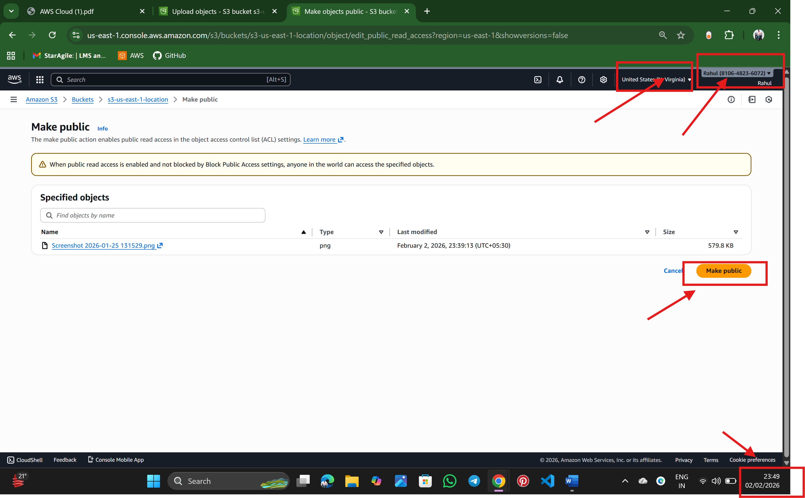

Step:7 copy the object URL

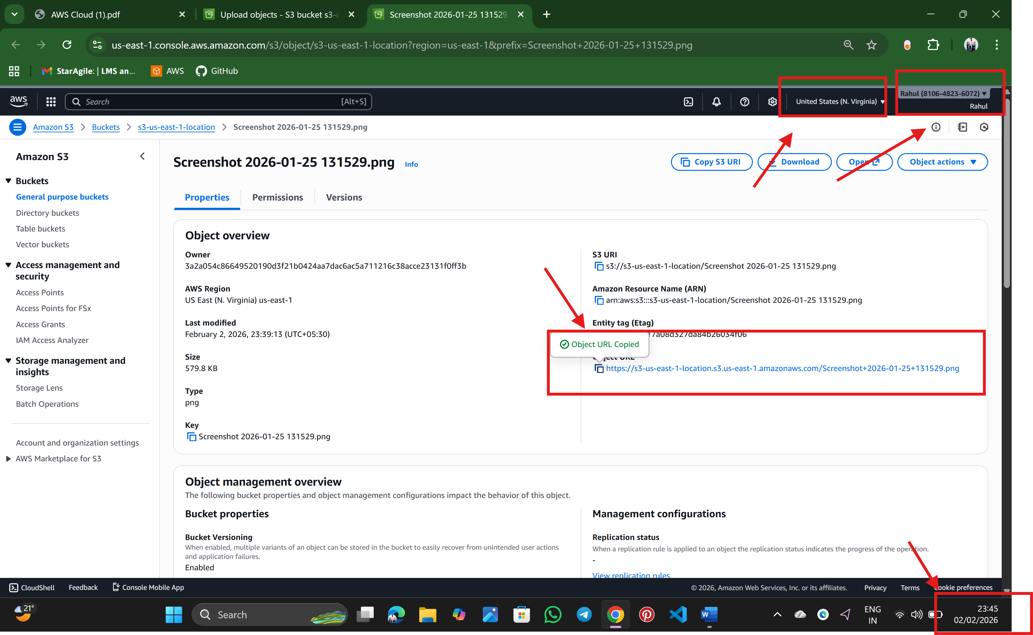

Step:8 open new browser and paste the object URL

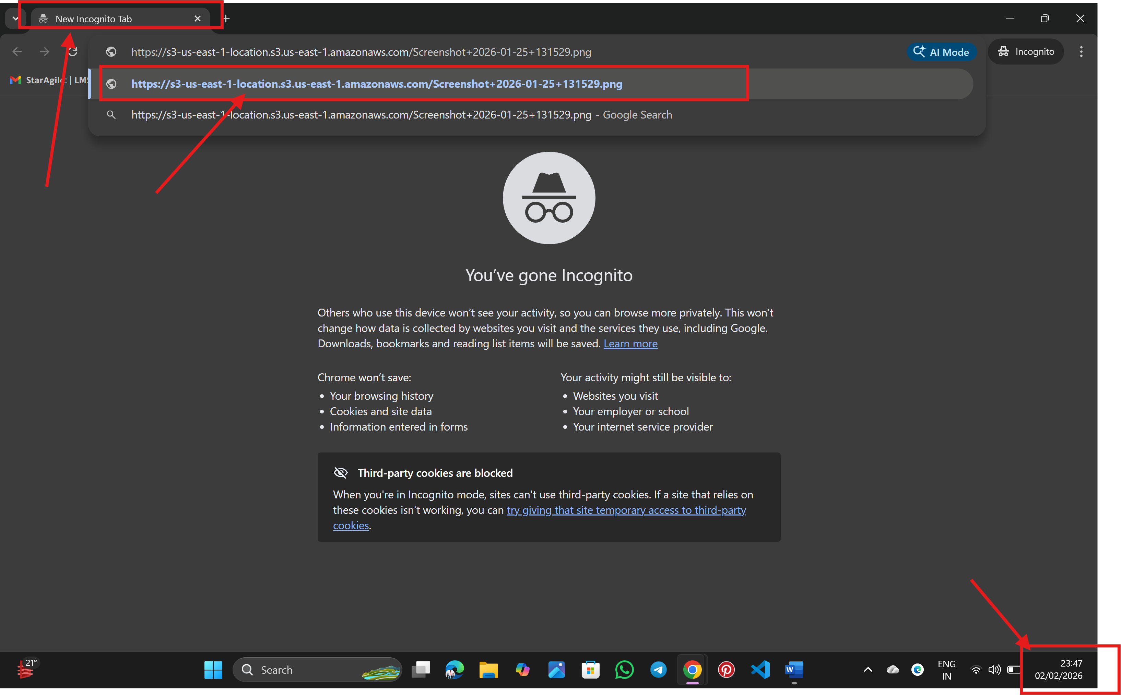

Step: 9 finally, we can see the files

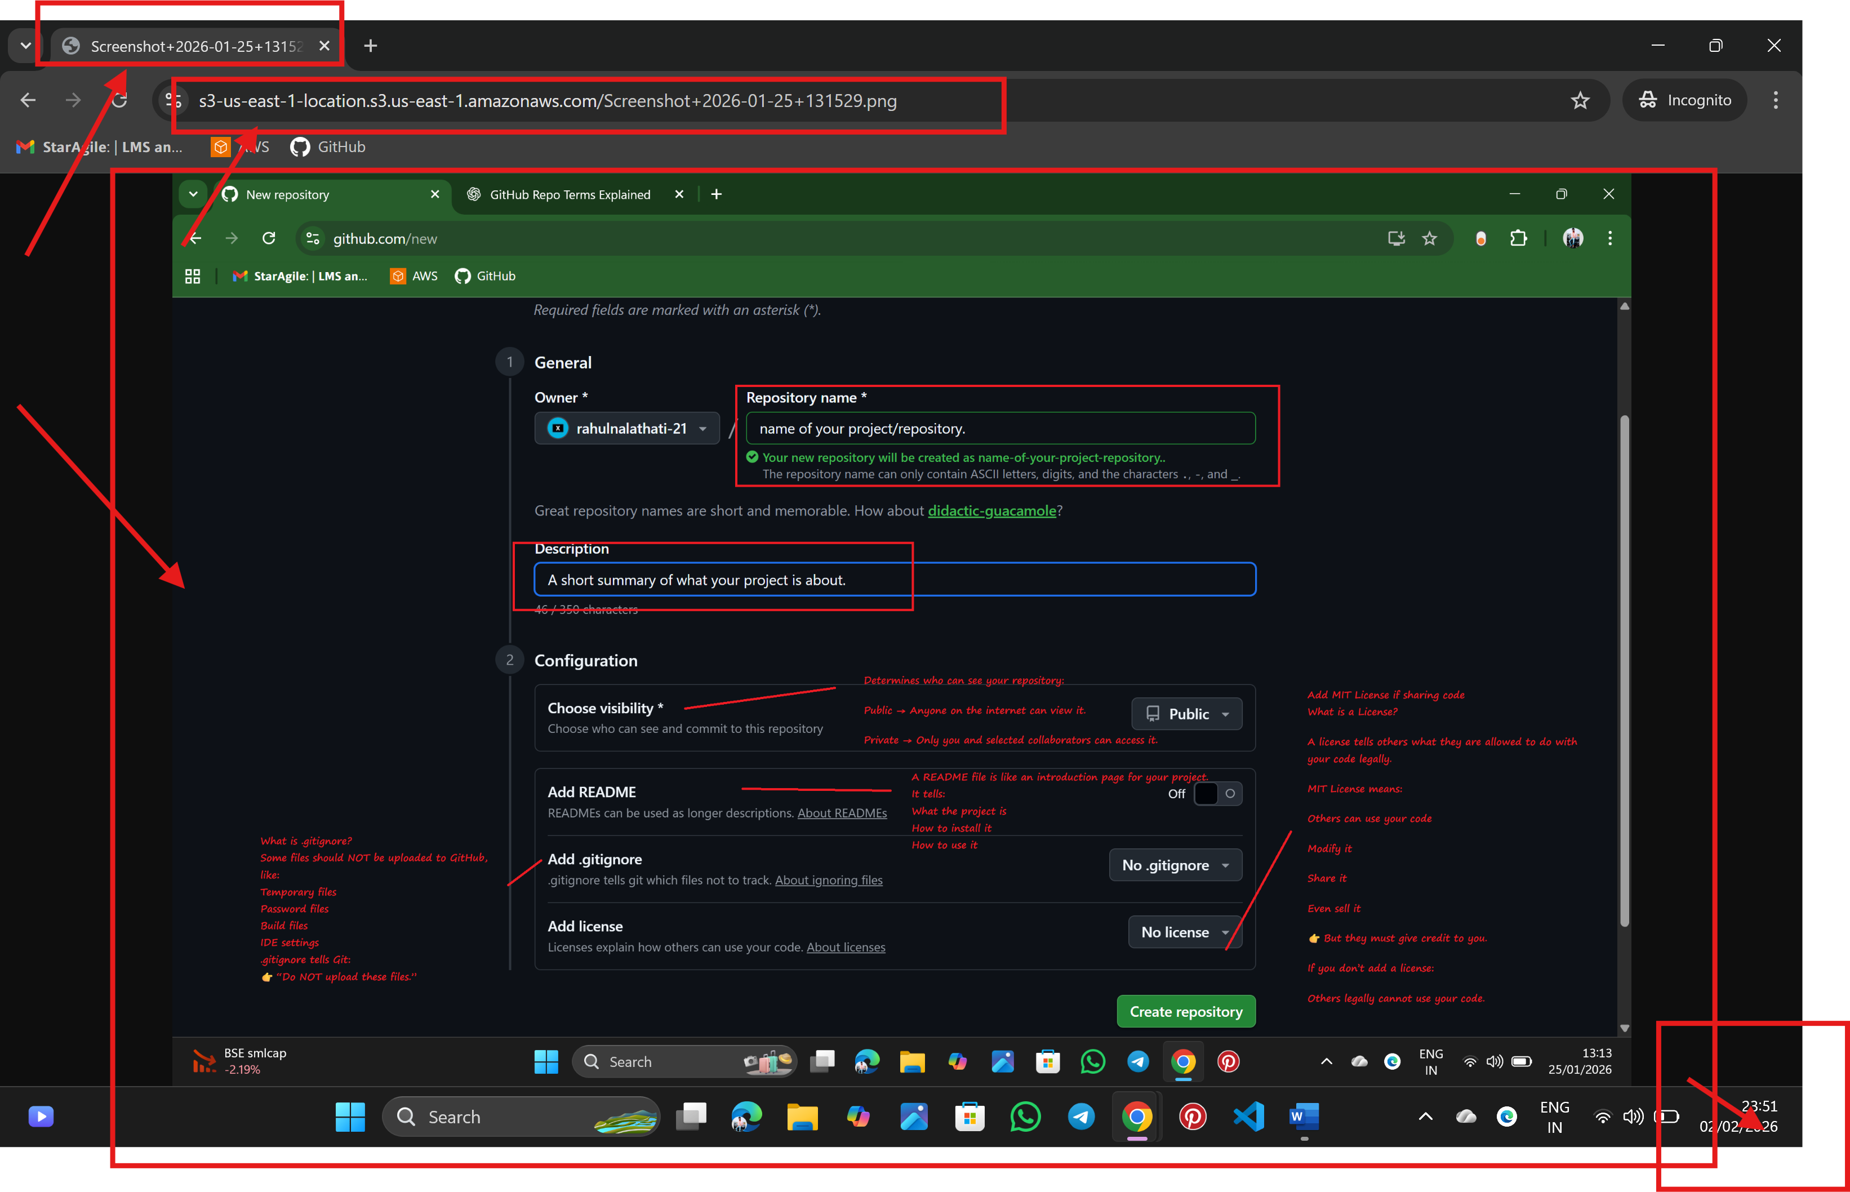

🡪Rahul Nalathati